Mohammad Widyarta

Universitas Indonesia

**Liem Bwan Tjie (1891- 1966)**

Liem Bwan Tjie was an Indonesian architect. He was born in Semarang and died in Rijswijk, Netherlands. Along with FRIEDRICH SILABAN, Mohamad Susilo and others, in 1959 he founded the Ikatan Arsitek Indonesia (IAI, Indonesian Institute of Architects). He studied at the Technische Hogeschool, Delft (now University of Technology, Delft). Then, he continued his studies in China, at Yenching University. Liem went back to practice in Semarang in 1929, where he found an important patron, Oei Tiong Ham, the sugar baron of South East Asia in the pre-World War II era, before moving to practise in Jakarta in 1938, where he would continue working up to 1965.

Liem Bwan Tjie’s works show influences of Willem Dudok and FRANK LLOYD WRIGHT. An early work of Liem in Semarang, a stand for Coffee Margoredjo at the Semarang Annual Fair (1929) shows a rather CUBIST, almost Dudok-like, massing of elements. The influence of Dudok is more apparent in his work in Semarang, Oei Tiong Ham Concern (1930). The massing of this work can be compared to that of Hilversum’s Town Hall by Dudok.

Another of Liem’s works, Han Tiauw Tjong’s Residence in Semarang (1932) shows an influence from Frank Lloyd Wright. The horizontality of the house recalls that of Wright’s Robie House.

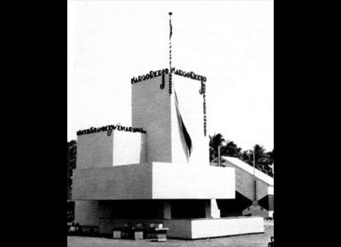

Coffee Margoredjo stand at the Annual Fair, Semarang, 1929 (Source: Nederlands Archtectuurinstituut/Bonas archive, <http://zoeken.nai.nl/CIS/project/16583>).

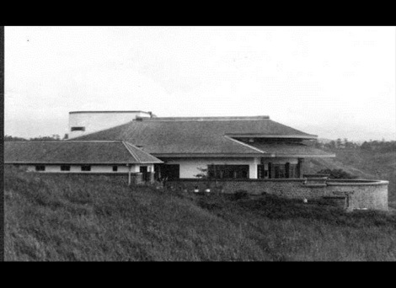

Han TiauwTjong Residence, Semarang, 1932. An attempt to apply principles of Lloyd Wright’s prairie school in Indonesian setting (Source: Nederlands Archtectuurinstituut/Bonas archive, <http://zoeken.nai.nl/CIS/project/16515>).

**List of Works**

1929 Coffee Margoredjo Stand, Semarang Annual Fair.

1930 Oei Tiong Ham Concern, Semarang.

1932 Han Tiauw Tjong’s Residence, Semarang.

1951 Food and Mouth Diseases Institute, Surabaya.

1953 Sport Stadium, Medan.

1961 Universitas Sam Ratulangi Campus, Manado.

**References and Further Reading**

Handinoto (2004) “Liem Bwan Tjie: Arsitek Modern Generasi Pertama di Indonesia ((1891 – 1966),”*Dimensi Teknik Arsitektur* 32 (2), 119 - 130.

Handinoto, N. Purwestri, & M.N. Widyarta (2012) “Liem Bwan Tjie (1891 – 1966) dan Perkembangan Arsitektur Modern di Indonesia,” in *Tegang Bentang: Seratus Tahun Perspektif Arsitektural di Indonesia*, Jakarta: Gramedia & Pusat Dokumentasi Arsitektur Indonesia.